Obecní úřad Úholičky

a

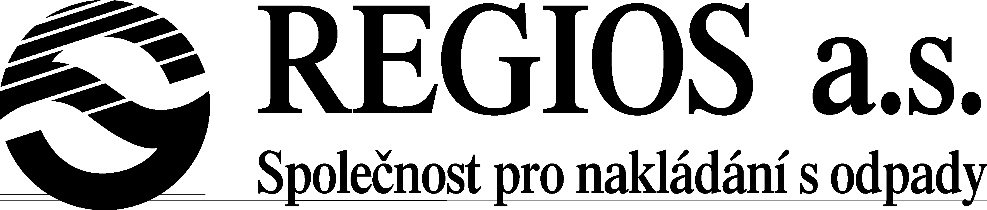

Plan for collection of hazardous waste for Uholicky

Date: Saturday 28.9.2013 from 9:30 – 11:30

Private individuals may deposit their hazardous waste free of charge. List of items that will be collected:

- Florescent lights and bulbs
- Car batteries and regular batteries
- Used oils and oil filters, including their containers
- Used deep-fryer oil
- Paint or laquer, including their cans/containers
- Acids, thinners, cleaners and other home chemicals
- Spray cans
- Old medicine
- Refrigerators
- Televisions

9.30 - 10.05 in the village square

10.10 - 10.40 Chaloupky

10.45 - 11.30 Podmoráň

